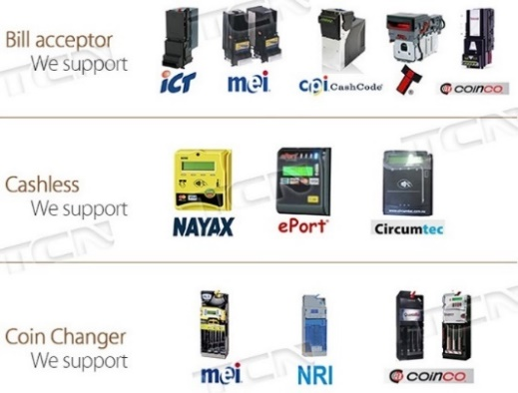
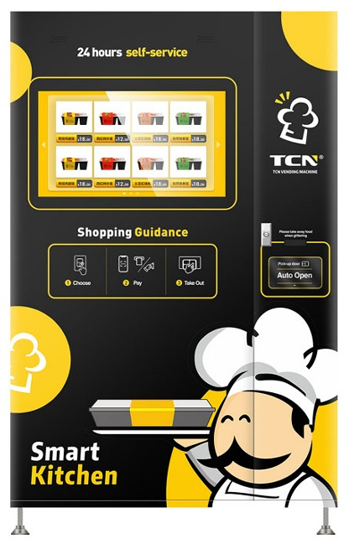
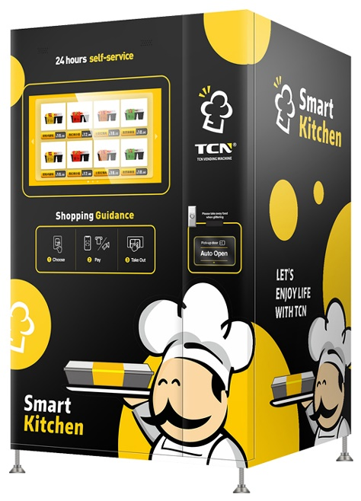
FEATURES
- Built-in microwave heats fresh food to hot meal in 60 seconds  - Advanced water-cooling system |  |  |  | - 32-inch touch screen - user friendly machine interface for easy programming, changing settings, pricing and advertising
- Dispenses pre-packaged fresh food to microwave heating before delivery |  |  |  | - Energy efficient compressor, LED lighting, advanced foam insulation technology etc.
- Coil (conveyor belt optional) with steady crawler belt dispensing with automatic X-Y pickup delivery |  |  |  | - Modular design – easy front removal of cooling unit for timely maintenance or repairs
- Self fault-diagnostics for easy maintenance |  |  |  | - Standard MDB & DEX protocol interface
- Cryogenic preservation & ozone disinfection |  |  |  | - Digital price labels allowing easy price adjustments
- Accepts latest in cashless payment and telemetry system brands and products incl PayPassTM, payWaveTM, Android/Google PayTM, Apple PayTM etc. |  |  |  | - Uses R134a refrigerant and RoHS compliant  - Video: https://www.youtube.com/watch?v=M3ECp5f2d-Y
MODEL |  |  |  | CFM-4C(H32)  TOUCH SCREEN MICROWAVE & X-Y CRAWLER BELT
Size (number of standard products wide) |  |  |  | Extra Large (12)
Outside Dimensions (w x d x h) mm |  |  |  | 1,220 x 1,015 x 1,945
Net Weight/Ship Weight (kg) |  |  |  | 400/435
Number Selections |  |  |  | Up to 72
Storage Capacity (number of products) |  |  |  | Up to 720
 |  |  |  | 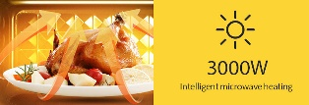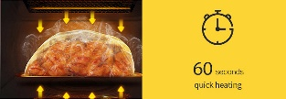 |  |  |  | 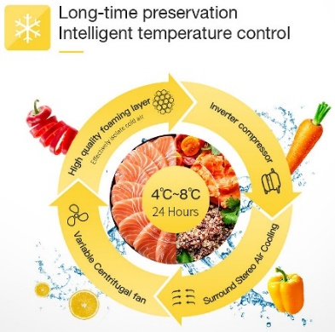
 | WARRANTY  Machine: 12 months  LOCAL SUPPORT  Including unlimited over-the-phone/video support
Payment Systems |  | Coin, note/bill, credit/debit card, mobile, ID card, NFC card, RS232 etc.
Cooling Function |  | Japanese brand EmbracoTM compressor refrigeration: +1 to +55 °C (adjustable) (heating +70 °C)
Refrigerant |  |  |  | R134a
Rated Power (Vac)/Frequency (Hz) |  |  | 220-240/50 | Power Consumption (W) |  |  | 750 to 3,000 (220-240Vac/20A)
Contact:  Vendpro  Unit 3, 23 Geddes Street, Balcatta, Perth, WA 6021  P: 08 9240 1333 | E: info@vendpro.com.au | W: www.vendpro.com.au |  |  |  |  |  | 
 |  |  |  |  |  | MicroMarket, Vending & Convenience Foodservice Solutions

